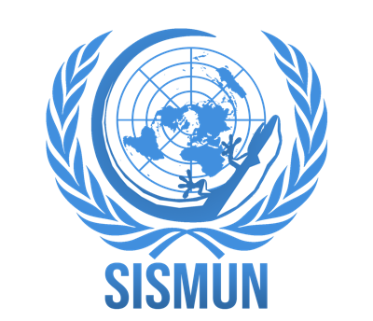
PRESS TEAM
SISMUN Shenzhen 2021 Application Form
RETURN BY: 30 June 2021

Students must return this form along with a Statement of Intent.

The Statement of Intent should include the students’ Press Team (or related)/MUN experience and should outline how they can contribute to the conference.

Applicants: Return the complete application (form + letter of motivation) by email to: twallace@sis.org.cn, 22sp02@sis.org.cn , and sismodelunitednations@sis.org.cn
First Name: ________ Family Name: ________
M/F: Nationality: Date of Birth (D/M/Y):
Name of School:
Grade/form/class in 2021 (Aug):
Preferred Email:
Wechat ID:

Press Team (or related) /MUN Experience:
Year | Conference | Position

I HEREBY APPLY for Press Team position at SISMUN, in October 22nd-24th , 2021.

I WOULD PREFER, if possible, to serve as (rank them):

Photographer ( )
Video Editor ( )

Date (d/m/y):
Signature:

Statement of Intent (250-300 words):

